UofL Research & Innovation Website Renovation

Vision (Small Project)

Version <2.0>

Revision History

|  |  |  |  |
| --- | --- | --- | --- |
| **Date** | **Version** | **Description** | **Author** |
| <27/Jan/20> | <1.0> | <First Iteration> | <Ruomei Wang> |
| <10/Feb/20> | <2.0> | <Second Iteration> | <Sohal Patel> |
|  |  |  |  |
|  |  |  |  |

Table of Contents

1. Introduction 4

1.1 References 4

2. Positioning 4

2.1 Problem Statement 4

2.2 Product Position Statement 4

3. Stakeholder and User Descriptions 4

3.1 Stakeholder Summary 5

3.2 User Summary 5

3.3 User Environment 5

3.4 Summary of Key Stakeholder or User Needs 6

3.5 Alternatives and Competition 6-7

4. Product Overview 8

4.1 Product Perspective 8

4.2 Assumptions and Dependencies 8

5. Product Features 9

6. Other Product Requirements 9-10

7. Appendix A 10

Vision (Small Project)

# Introduction

This vision document is to collect, analyze and define high-needs and features of the University of Louisville Research and Innovation website renovation. The document focuses on the capabilities needed by the stakeholders and the target users, and the improvements provided by the renovation.

## References

1. Ambler, Scott W, and Matthew Holitza. “*Agile For Dummies®, IBM Limited Edition*.” Print.

2012.

2. Dennis, Alan, et al. *Systems Analysis and Design with UML, 4th Edition*. John Wiley & Sons,

2012.

3. *Front Page - Research and Innovation*, University of Louisville, louisville.edu/research.

# Positioning

## Problem Statement

|  |  |
| --- | --- |
| The problem of | The UofL Research and Innovation webpage being difficult to navigate |
| affects | UofL students and faculty, researchers, industry |
| the impact of which is | Results in less researchers, students, and organizations involved in this program, and in the end affects the revenue of UofL research office |
| a successful solution would be | Renovate the website menu and layout |

## Product Position Statement

|  |  |
| --- | --- |
| For | UofL Research Center |
| Who | Needs more revenue to fund research |
| The (product name) | A website |
| That | Attracts more industry and conducts further research |
| Unlike | Other research instructions and facilities |
| Our product | Clear layout and navigation for target customers |

# 

# Stakeholder and User Descriptions

## Stakeholder Summary

|  |  |  |
| --- | --- | --- |
| **Name** | **Description** | **Responsibilities** |
| Louisville community | Residents of Louisville who want success for our University | Residents of Louisville can promote our University’s research and innovation |
| University of Louisville employees | UofL employees who wants to see our University thrive on research | UofL employees can work more efficiently and effectively to help approve findings and monitor research progress |
| Louisville Metro Government | Louisville government that helps UofL become a better University | Louisville government can maintain a safer environment for UofL students and researchers |

## User Summary

|  |  |  |
| --- | --- | --- |
| **Name** | **Description** | **Responsibilities** |
| Students | UofL students who wants to participate in research | Engage in learning and participate in research actively |
| Researchers | UofL researchers who want to innovate and discover new things | Lead students to rewarding and meaningful research, and provide the industry better solutions |
| Industry | Industry that needs technology solutions and advanced knowledge | Reach out to our University and help conduct the solutions given by the researchers |

## User Environment

1. Students: Students need to have the information available to make an educated decision about their choices for attending a university. The prospective student needs to be able find information on degrees offered, tuition and costs, the admissions and application process, admission requirements, and deadlines for admissions and registration. Many students also need to know about scholarships, housing, and student aid.

It is not easy to see the research area, latest available opportunities, latest news, admission requirements and procedures. This information will affect number of students who apply and join the program.

1. Researchers: It is not easy to find all the research activities like meeting dates, new projects, and resources. This causes delays in producing research and affects the number of projects the university undertakes.
2. Industry: Universities depends on donations and endowment for many of their operations regarding to the institution. Not having enough university industry collaborations affects the university.

## Summary of Key Stakeholder or User Needs

|  |  |  |  |  |  |
| --- | --- | --- | --- | --- | --- |
| **Need** | **Priority** | **Concerns** | **Current Solution** | **Proposed Solutions** | |
| Getting more funding for UofL research | High | UofL research website is not intuitive enough to help users navigate information | Renovate the menu and layout.  Addition of some internal hosted modules to virtual assistance or explanation in for of animation, video or multimedia modules. | | Overhaul the website to make it more intuitive, create better design and helpful for researcher and learners to obtain meaningful material. |

## Alternatives and Competition

|  |  |  |
| --- | --- | --- |
| **Institution Name** | **Strengths** | **Weaknesses** |
| University of Kentucky | * Clear display of achievement and breakthroughs * Event Announcements on main page * Request for Visit Application integration | * Lack of an intuitive navigation menu * Hard to find funding information * No landing initializing on click on any mentioned menu |
| Indiana University Bloomington | * Great website design * Good narratives about research achievements * Research Page is very helpful and link regarding to requirements | * Lack of an intuitive navigation menu * Body content is not attractive for a user to stay and read full page * Some buttons could be confusing * Hard to find funding information * Footer menu Color Combination is not making attractive or not looking as its part of website |
| Ohio State University | * Dedicated section for research news * Main Menu Management | * Website is too simple, not substantial or concrete enough * Hard to find funding information * Website is not optimized * No contact US form Integration for direct email or message sending to the admin * No proper menu button in Contact US section for asking question, information Section, Virtual tour and Coming up. |
| Yale University | * Great website design * Clear separation for different users between researchers and industry * Proper Admission Guideline and requirement * Searching by keyword | * No dedicated entrance button for students * Hard to find funding information * Header color is emerged not so well to describe a header * Copyright footer space Between typography and lower line * Color Combinations of Footer and whole website is not so well. * Contact US form not Integrated for Direct message of Direct email from same page * Student Section Domain is separate |

# Product Overview

## Product Perspective

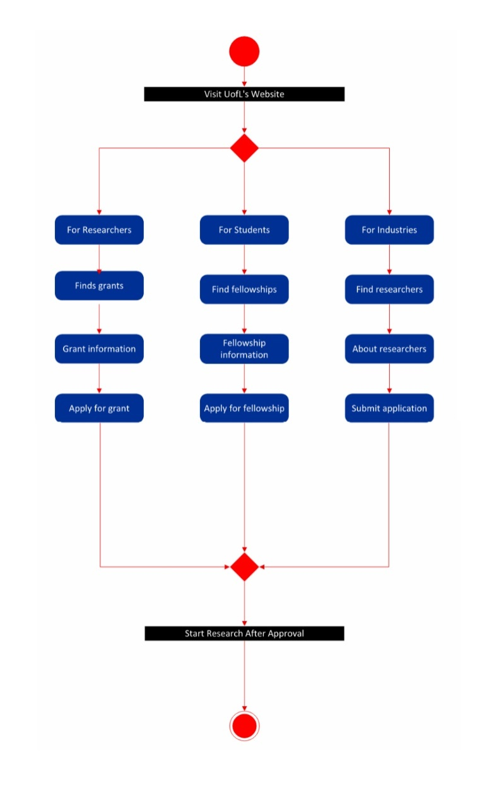

## Assumptions and Dependencies

1. The default language will be English. It is assumed that users who cannot speak and write in English will also can change language with built in function of our website to change desired language.
2. When using the search feature, it is assumed that users are literate, also able to identify actually what he or she is looking forward on this platform.
3. It is the basic requirement to have website address and a working network on any machine with web browser to access website.

# Product Features

1. Intuitive and Responsive Navigation Menu
2. User Friendly GUI Design
3. Separation of Resources for Different User Groups
4. Updates About Recent News and Latest Researcher Meetings and Conferences News
5. Announcement Regarding To New Research Program
6. Newsletter Subscription Through Email
7. Admission Requirements And Procedure
8. Integration Of Fund Transfer Protocols
9. Dedicated section of Funding Information

# Other Product Requirements

1. Academic:

* Provide More Resources to Students: By striking up corporate partnerships, universities have more resources to undertake research, and they’re able to diversify their research areas.
* Moving in the Market: Universities know that some problems can’t be solved in isolation in a lab, and industry feedback is key to taking an invention or product from conception to market.
* Expose Students to the Industry Culture: Companies are hungry for ideas, and the actual technologies and intellectual properties to commercialize those ideas. And, companies are hungry for talent. This is a very good opportunity to expose students to the industry culture. When students graduate, they are better prepared to start working at these companies.
* The benefits for companies continue to stack up, including access to a network of faculty, key opinion leaders, and lead scientists, and the ability to team up with other companies interested in the same research.

1. Organizational:

To measure how well the system ultimately will be accepted by its users and incorporated into the ongoing operations of the organization, there are many organizational factors that can have an effect on the project, and developers know that organizational feasibility can be the most difficult feasibility dimension to assess. In essence, an organizational feasibility analysis attempts to answer the question – If we build it, will they come?

* Project Champion(s)

A champion: Initiates the project, promotes the project, allocates his or her time to project, and provides resources.

* Organizational Managers

Know about the project, budget enough money for the project, encourage users to accept and use the system.

* Users

Make decisions that influence the project, perform hands-on activities for the project, and ultimately determine whether the project is successful by using or not using the system.

# Appendix A

